11th July 2016

**FIA ETCC TITLE DECIDER TO WAIT FOR LAST RACE IN IMOLA**

Incredible motorsports action, drama and spectacular scenes were the order of the day at the FIA European Touring Car Cup races at the weekend. With YOKOHAMA as Official Tyre supplier to the Championship and the two main contenders going all out for the Super 2000 title, the intense battle in Magny-Cours last weekend did not clarify who will come up victorious at the end of the season. Everything is now on hold until the very last race meeting to be held in early October at the legendary circuit of Imola in Italy.

Petr Fulin and Kris Richard are now tied on 92 points following Fulin’s race 1 victory, courtesy of Richard’s mistake that took him to pit-in unnecessarily and Richard fighting back with a win in the second race at Magny-Cours.

The Czech SEAT Leon driver Petr Fulin’s fourth win of the season followed an unexpected turn of events as the Swiss Honda Civic driver Kris Richard pitted from the lead in error, having mistaken a Black and White driving standards flag as an instruction for a drive through penalty. Upon realising, he tried to recover some positions but was unable to make it to recover the lead and had to settle for fourth.

However he did make up for his race 1 confusion and stormed from 5th on the grid to first to take the win, his fifth in his first FIA ETCC season. Fulin, also had a superb race 2, starting from 8th on the grid and coming up in second place.

In the best of the rest, Peter Rikli also obtained some valuable points and is now third overall on 57 points whilst Norbert Nagy is closely behind in fourth on 54 points.

In the Super 1600, the German Niklas Mackschin was all celebrations as, subject to official confirmation, he wrapped up the division title for the second consecutive year with a great performance at Magny-Cours with a third and second place, making the distance between him and his immediate pursuers unassailable.

All eyes will now be on the thrilling title showdown in Italy’s Imola circuit in early October.

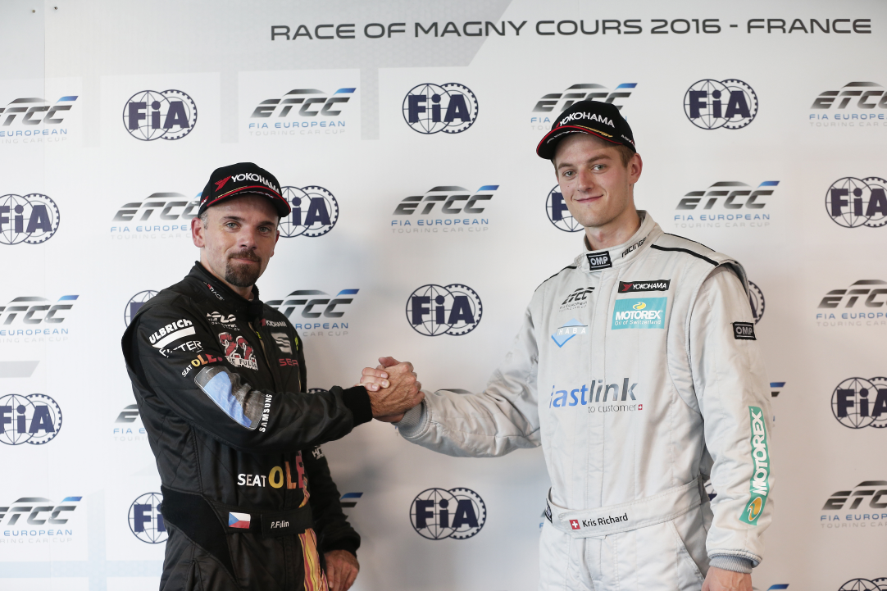

*FIA ETCC Petr Fulin and Kris Richard greet and look forward to decider races in Imola*

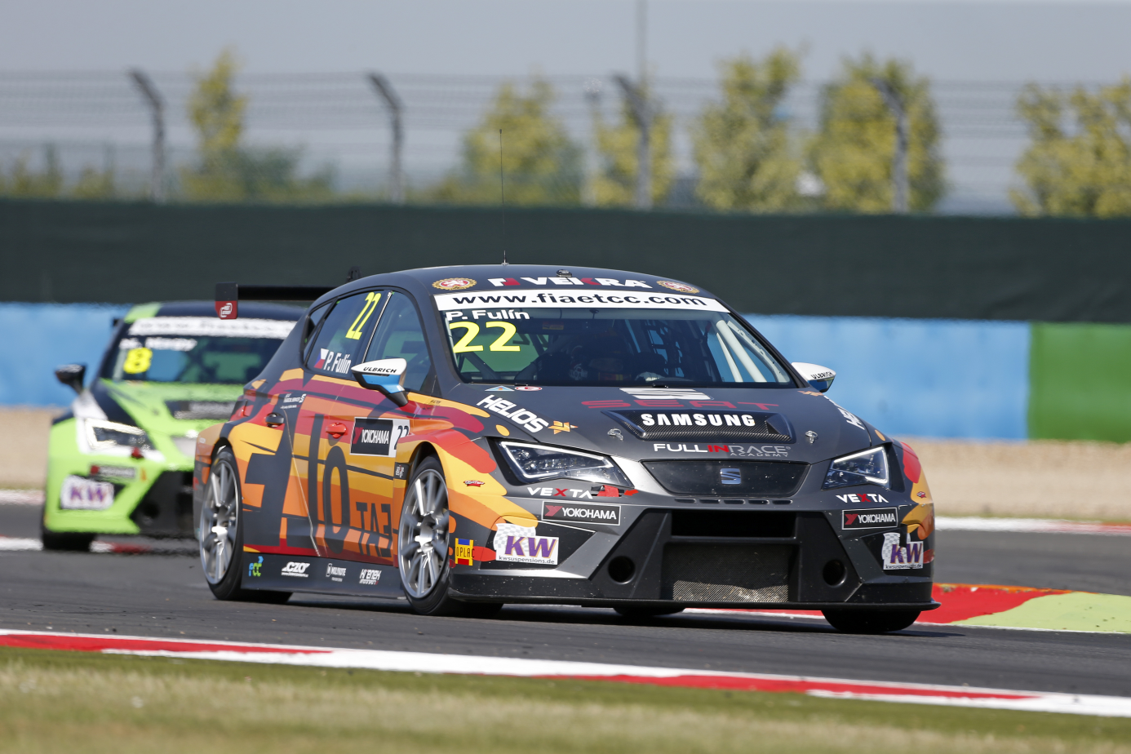

*Petr Fulin battles it out in Magny Cours on his SEAT Leon*

*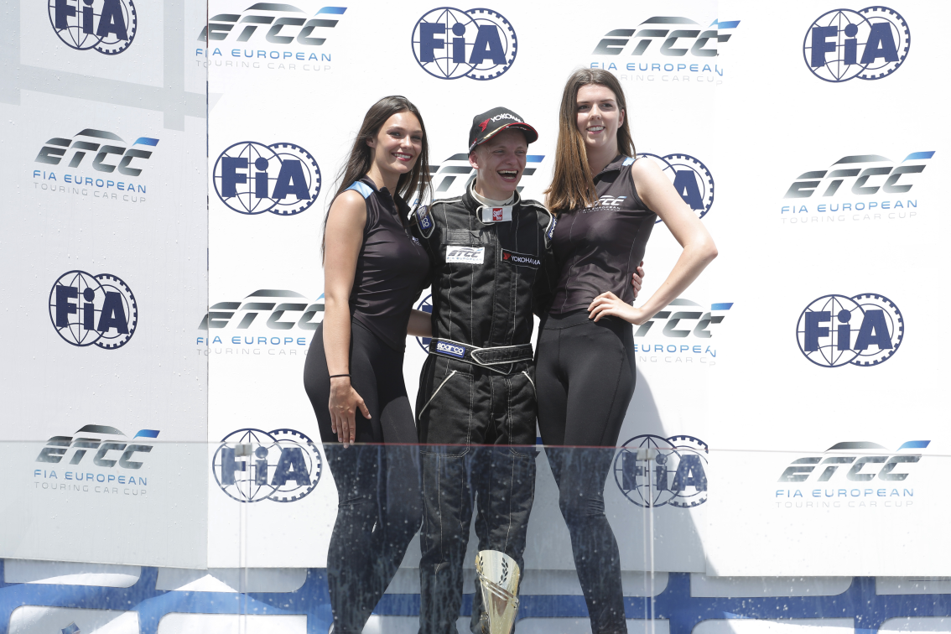  
Niklas Mackschin to be crowned FIA ETCC Champion in the Super 1600 class*